Final Project Report

EMAIL MODERATION ENGINE



Project Supervisor
Tanveer Arshad

Submitted By

S11CS619AFA4C

Meraj Rasool MC080203420

Software Projects & Research Section,
Department of Computer Sciences,
Virtual University of Pakistan


CERTIFICATE

This is to certify that Meraj Rasool (MC080203420) have worked on and completed their Software Project at Software & Research Projects Section, Department of Computer Sciences, Virtual University of Pakistan in partial fulfillment of the requirement for the degree of Masters in Information Technology under my guidance and supervision.

In our opinion, it is satisfactory and up to the mark and therefore fulfills the requirements of Masters in Information Technology.

Supervisor / Internal Examiner

Tanweer Arshad
Supervisor,
Software Projects & Research Section,
Department of Computer Sciences
Virtual University of Pakistan

___________________
(Signature)

External Examiner/Subject Specialist
<<External Supervisor Name>>

___________________
(Signature)

Accepted By:

_____________
(For office use)

EXORDIUM

In the name of Allah, the Compassionate, the Merciful.

Praise be to Allah, Lord of Creation,
The Compassionate, the Merciful,
King of Judgment-day!

You alone we worship, and to You alone we pray for help,
Guide us to the straight path

The path of those who You have favored,

Not of those who have incurred Your wrath,
Nor of those who have gone astray.

DEDICATION

To My Parents, Family Members
and Teachers
ACKNOWLEDGEMENT

First of all, I would like to thank Allah SWT who has helped me in everything.

I will then thank my family members who acknowledged and let me study and work on this project as it would have been very tough to complete with my full time job unless their help and understanding.

I will also thank VU and its teachers for giving us this opportunity to study at the comfort of our home and get a world class recognized degree at my door step. I really appreciate the great work they are doing.
PREFACE

This document describes and explains the process through which I went through while working on Email Moderation Engine.

It explains the different methodologies and approaches I evaluated and adopted.
TABLE OF CONTENTS

CHAPTER NO. 1
gathering & Analyzing info 10

1.1 Introduction

1.2 purpose

1.3 scope

1.4 definitions, acronyms and abbreviations

1.5 use cases and usage scenarios

1.5.1 Use Case Diagrams

1.5.2 Usage Scenarios

1.6 supplementary requirements

1.6.1 Usability

1.6.2 Reliability

1.6.3 Supportability

1.6.4 System Requirements

CHAPTER NO. 2
planning the project 18
2.1 Introduction

2.2 Methodology

2.3 Available Methodologies

2.4 Chosen Methodology

2.5 Reasons for Chosen Methodology

2.6 Work Plan
2.7 Project Structure

2.7.1 Team Structure

2.7.2 Project Schedule

CHAPTER NO. 3
designing the project 24

3.1 Introduction

3.2 purpose

3.3 scope

3.4 definitions, acronyms and abbreviations

3.5 Architectural Representation

3.6 Architectural Goals And Representation

3.7 Dynamic Model: Sequence Diagrams

3.8 Object Model/Logical Model: Class Diagram

3.9 Implementation View

3.9.1 Overview

3.10 Deployment Model

3.11 Database Model

3.12 Graphical User Interfaces

Chapter no.4
DEvelopment 36
4.1 Development plan
4.1.1 Evaluation
4.1.2 Framework
4.1.3 Custom MVC

4.2 Source code

Chapter no.5
DEployment 38
5.1 Deployment Plan
5.1.1 Setup Requirement
5.1.2 Deployment

CHAPTER 1
Gathering & Analyzing Info

1.1 INTRODUCTION

This software EME (Email Moderation Engine) is a web based client which reads email from a POP server and displays in web page requested with in a web browser.

EME also provides some unique features like setting reminder or priorities on emails to follow up further.

1.2 PURPOSE

Email client to send and receive emails and also give the flexibility to set reminder or prioritize emails.

1.3 SCOPE

This project will be a web email client application. This will provide user the ability to send, receive, flag and set reminders on individual email(s).

User will be able to flag and set reminders to individual email(s). After making changes to an email by updating flag for it or adding reminder, the client app will save this information to server and on each login it will check and display the emails according to that in separate pane(s) according to their priorities.

Once the reminder's date and time reaches, it will show a popup to user to do that specific action. In case user is not logged in to client and reminder's time is reached, user will be sent an SMS via a daemon which would be running on server.

1.4 DEFINITIONS, ACRONYMS AND ABBREVIATIONS

Email – Electronic Email
EME – Email Moderation Engine
POP – Post Office Protocol
Browser – Software to access internet from PC

1.5 USE CASES AND USAGE SCENARIOS

1.5.1 Use Case Diagrams
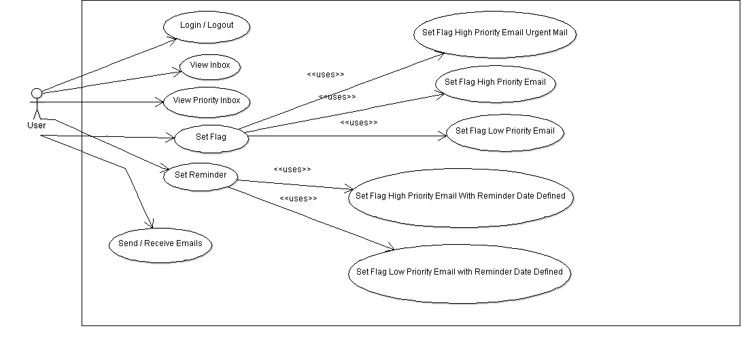

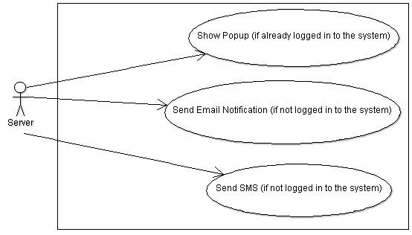
1.5.2 Usage Scenarios

1.5.2.1 Login:

Use Case Name | Login
Use case ID | UC-01
Action | - Users can access his email account by logging in.
Description | - User can view his emails by logging in.
Precondition | - User should have correct credentials to logon to the system.
Alternative Paths | - If user ID or password is incorrect, user will be redirected to login page again with an error message displayed on the screen.
Post condition | - After login, user should be able to view his emails according to the priorities he set in different panes.
Exception Paths | - The system wouldn’t allow user access if user ID and password are not correct.  - In case the server is down, the user will not be able to logon to it.
Author | MC080203420 (Meraj Rasool)

1.5.2.2 Logout:

Use Case Name | Logout
Use case ID | UC-02
Action | - User can end their session by logging out.
Description | - User will no longer be able to view his emails.
Precondition | - User should be logged in to the system.
Alternative Paths | None
Post condition | - After logout, user’s session should be cleared and user or no one else should be able to view his email(s) and other preferences.
Exception Paths | - In case the system is down, user will not be able to clear his session hence he couldn’t logout.
Author | MC080203420 (Meraj Rasool)

1.5.2.3 Inbox:

Use Case Name | Inbox
Use case ID | UC-03
Action | - The system will fetch emails from server and display in inbox. User can see all his emails in inbox.
Description | - User can view his emails in inbox.  - User can update status of his emails in inbox.
Precondition | - User should be logged in to the system.
Alternative Paths | None
Post condition | - Inbox should show all emails of user with their correct status (read/unread) and flags.
Exception Paths | - In case the server is down, client will not be able to fetch user’s email and a proper message will be displayed to user.
Author | MC080203420 (Meraj Rasool)

1.5.2.4 Priority Inbox:

Use Case Name | Priority Inbox
Use case ID | UC-04
Action | - The system will fetch emails from server and display in priority inbox according to their flags. E.g. High Priority on top, lower priority under that and so on.
Description | - User can view his emails with correct flags in priority inbox.  - User can update status of these emails in priority inbox.
Precondition | - User should be logged into the system.  - User should already have some flagged emails.
Alternative Paths | None
Post condition | - Priority Inbox should have emails which have been flagged for different priorities.  - Emails will be shown in different panes according to their priorities.
Exception Paths | - In case the system is down, client will not be able to fetch user’s email and a proper message will be displayed to the user.
Author | MC080203420 (Meraj Rasool)

1.5.2.5 New Message:

Use Case Name | New Message
Use case ID | UC-05
Action | - The system will let user type a new email in an editor.
Description | - User can type in a new email as done in normal editor.
Precondition | - User should be logged into the system.
Alternative Paths | None
Post condition | - Clicking on New message should open editor for composing a new email.
Exception Paths | None
Author | MC080203420 (Meraj Rasool)

1.5.2.6 Send Email:

Use Case Name | Send Email
Use case ID | UC-06
Action | - User can send new email.
Description | - User should be able to compose and send an email.
Precondition | - User should be logged in to the system.  - User should have written a message in compose editor.
Alternative Paths | - In case user didn’t provide any recipient user will be shown a message to provide recipients.
Post condition | - Once user has written an email, he should be able to send this email to the recipients he provide.
Exception Paths | - In case SMTP server is down, user will be shown a proper message that email is not sent due to this reason.
Author | MC080203420 (Meraj Rasool)

1.5.2.7 Receive Email:

Use Case Name | Receive Email
Use case ID | UC-07
Action | - User could receive email.
Description | - User should be able to receive any new emails sent to him.
Precondition | - User should be logged in to the system.  - Some email(s) has been sent to this user’s email address.
Alternative Paths | None
Post condition | - Clicking on ‘Receive’ should fetch new emails from server sent to this user’s email address.  - Emails should be fetched with their priorities and all other attributes.
Exception Paths | - In case IMAP server is down, user will be shown a proper message that email(s) couldn’t be received due to this reason.
Author | MC080203420 (Meraj Rasool)

1.5.2.8 Set Flag:

Use Case Name | Set Flag
Use case ID | UC-08
Action | - User could set flag(s) on emails.
Description | - User should be able to flag(s) emails.
Precondition | - User should be logged in to the system.  - User should have some email(s) in priority inbox.
Alternative Paths | None
Post condition
Exception Paths | - In case server is down, user’s flag(s) will not be saved to the server and a proper message will be displayed to the user.
Author | MC080203420 (Meraj Rasool)

1.5.2.9 Set Reminder:

Use Case Name | Set Reminder
Use case ID | UC-09
Action | - User could set flag(s) on emails.
Description | - User should be able to flag(s) emails.
Precondition | - User should be logged in to the system.  - User should have some email(s) in inbox, which he could flag.
Alternative Paths | None
Post condition | - User should be able to set a reminder with date and time information for the following two priorities email:  - High Priority Email  - Low Priority Email  - Server should save this information to database.  - A script will be running 24hrs, which will periodically check (in 5-10 minutes interval) for these reminders. Once a reminder date and time is reached it will do the following:  - Show a popup on user’s screen if already logged in.  - Send an email notification and SMS to user if not logged in.
Exception Paths | - In case server is down, user will not be able to get any email notification / SMS.
Author | MC080203420 (Meraj Rasool)

1.6 SUPPLEMENTARY REQUIREMENTS

1.6.1 Usability

This software EME (Email Moderation Engine) has designed specifically for web browsers. It is supposed to work on every standard complaint browser. It supports desktop, tablet and mobile browsers.

1.6.2 Reliability

It has been tested against different POP servers and makes sure to not lose any of user’s email address while sending or receiving them.

1.6.3 Supportability

It has tested against two different POP servers Google and hMail. However, it is not limited to only these two and should work with any email server which supports POP and SMTP protocols.

1.6.4 System Requirements

Server:
- Email server having POP and SMTP enabled and accessible to the application.
- MySQL database for the database deployment.
- Apache server with PHP enabled in it.
- PEAR Packages (POP and Socket)
- At least 512MB RAM & 1Ghz processor.
- OS (Linux or BSD or Windows)

Client:
- Standard complaint latest browser with access to application.
- Access to internet if accessing via WAN otherwise LAN access would be required.

CHAPTER 2
Planning the Project

2.1 INTRODUCTION

One of the basic activities in any software developmental project is the development of the software plan. Planning Phase plays an important role in development of any software. In planning phase the developer estimates the software scope, resource requirements, time requirements, structural decomposition, work plan and risk. These estimates are documented so that they could be efficiently used throughout the project’s life cycle as an aid to track the progress of the software development. These documents are updated continuously throughout the planning phase.

Email Moderation Engine is a web-based application. Its goal is to help its users to prioritize and flag their emails according to its importance and later follow-up. It will help user respond on time and save their time.

This project (EME) requires an understanding of technology (computer language, database and project management). After completing this project, we will be able to have command on a full set of technologies required to build up software from scratch.

2.2 METHODOLOGY

Methodology is another name of process model. A process model is a series of steps through which the product progress is intended to reach a predefined goal. In software engineering the goal is to build a software product or make enhancement in the existing one. Process model provides a disciplined approach for assigning tasks and responsibilities. Process Model’s goal is to ensure the production of high-quality software product within a predefined schedule and budget that meets the needs of its end users.

2.3 AVAILABLE METHODOLOGIES

Following are some of the existing methodologies commonly used in software development projects now-a-days:

2.3.1 Agile:
Agile software development is a group of software development methodologies based on iterative and incremental development, where requirements and solutions evolve through collaboration between self-organizing, cross-functional teams. The Agile Manifesto introduced the term in 2001.

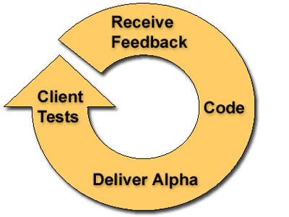

2.3.2 Iterative and incremental development:
Iterative and Incremental development is at the heart of a cyclic software development process developed in response to the weaknesses of the waterfall model. It starts with an initial planning and ends with deployment with the cyclic interactions in between.

Iterative and incremental development are also essential parts of the Rational Unified Process, Extreme Programming and generally the various agile software development frameworks.

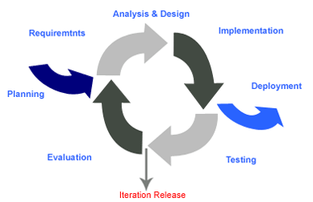

2.3.3 RAD (Rapid application development):
Rapid application development (RAD) is a software development methodology that uses minimal planning in favor of rapid prototyping. The "planning" of software developed using RAD is interleaved with writing the software itself. The lack of extensive pre-planning generally allows software to be written much faster, and makes it easier to change requirements.

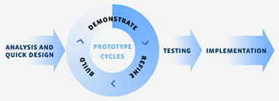

2.3.4 Spiral:
The spiral model is a software development process combining elements of both design and prototyping-in-stages, in an effort to combine advantages of top-down and bottom-up concepts. Also known as the spiral lifecycle model (or spiral development), it is a systems development method (SDM) used in information technology (IT). This model of development combines the features of the prototyping model and the waterfall model. The spiral model is intended for large, expensive and complicated projects.

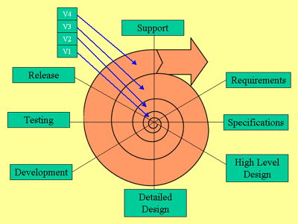

2.3.5 Waterfall:
The waterfall model is a sequential design process, often used in software development processes, in which progress is seen as flowing steadily downwards (like a waterfall) through the phases of Conception, Initiation, Analysis, Design, Construction, Testing, Production/Implementation and Maintenance.

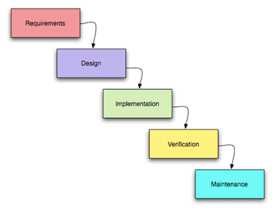

2.3.6 VU Model:
This model has predefined discrete stages. It provides a disciplined approach to assigning tasks and ensures the production of high-quality software. Each phase is verified before going to the next phase. It is a combination of waterfall and spiral models.

2.4 CHOSEN METHODOLOGY

After reviewing all the available process models, I feel none of the model will match exactly for my requirements except for VUP (which itself is a combination of waterfall and spiral models). I will adopt this methodology as using this, I will be able to verify each of my phase before starting working on next phase and it will help me make sure to keep the project on track.

2.5 REASONS FOR CHOSEN METHODOLOGY

I will be following the VUP model because this model's progress is according to my development needs. It has the following advantages over the others:

- Each phase is clearly defined and have been allotted specific days, which will help us plan accordingly.
- I believe this model is more suitable for our university's projects.
- No phase is complete until the documents / project status is checked and approved by QA.
- Good progress could be made sure due to the clear development phases.
- This model enforces clear documentation and working according to the deadlines, which will make sure it completes on time.

2.6 WORK PLAN

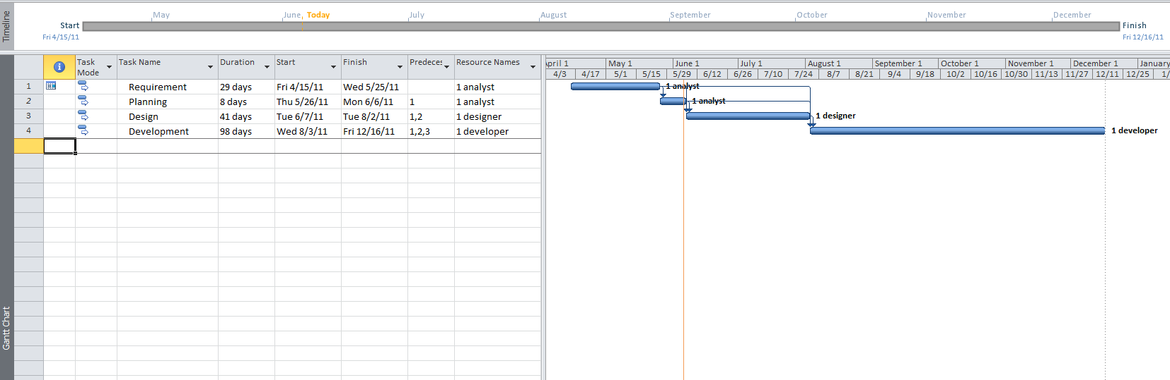

2.7 PROJECT STRUCTURE

2.7.1 Team Structure

The team for building this software comprised of one member. The same member worked as developer and analyst.

2.7.2 Project Schedule

CHAPTER 3
Designing the Project

3.1 INTRODUCTION

In design phase, we address different aspects of the project and according to the principals of software engineering we capture our thoughts using different diagrams and documents.

Following are the benefits of analysis and design:

- Think about problems we may face in future when actually implementing the application.
- Helps us think and know of obstacles before we actually start working on it.
- Helps us stream line our thoughts and later only focus on developing this according these.
- Helps in keep on right path for the project and during the development if we go on an incorrect path, these diagrams would help us get back on track.

3.2 PURPOSE

The purpose of this part is to explain the different pattern and technologies used during the design part.

It will also help the reader to equip the necessary knowledge to know the internals of the system.

3.3 SCOPE

This part illustrates the design phase. The scope for design will remain focused on achieving efficiency and great product.

3.4 DEFINITIONS, ACRONYMS AND ABBREVIATIONS

3.5 ARCHITECTURAL REPRESENTATION
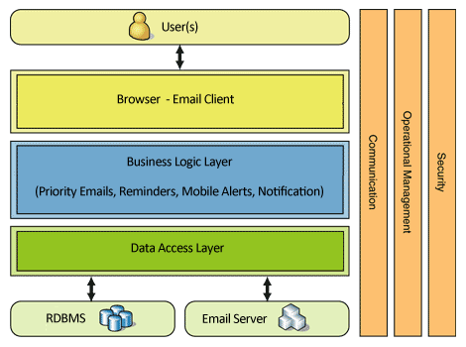

3.6 ARCHITECTURAL GOALS AND REPRESENTATION

To create and run the application with great efficiently and minimal resources.

3.7 DYNAMIC MODEL: SEQUENCE DIAGRAMS

3.7.1 Login:
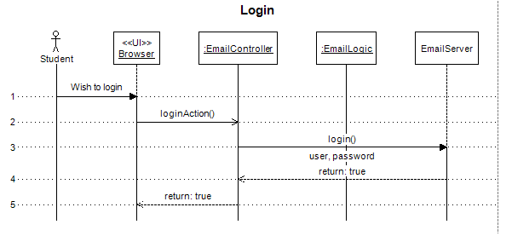
3.7.2 Logout:
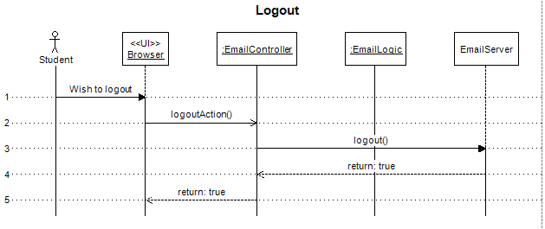

3.7.3 View Inbox:
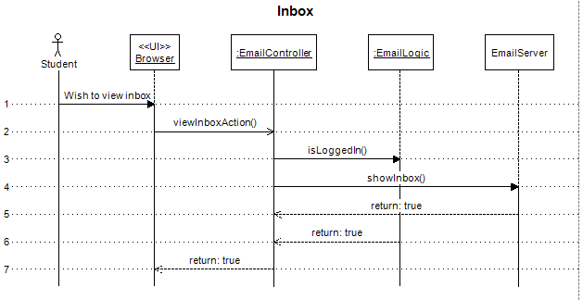
3.7.4 View Priority Inbox:
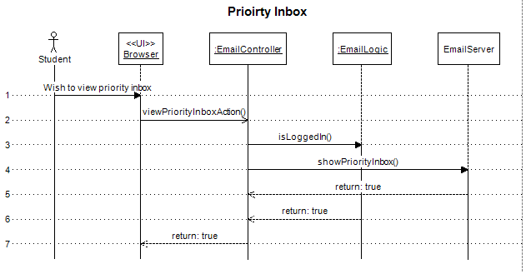
3.7.5 New Message:
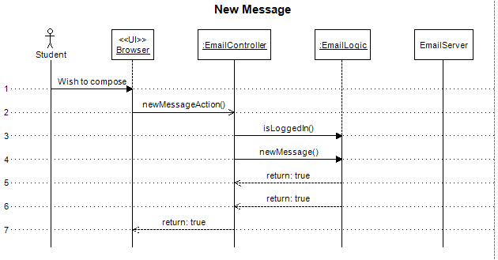
3.7.6 Send Email:
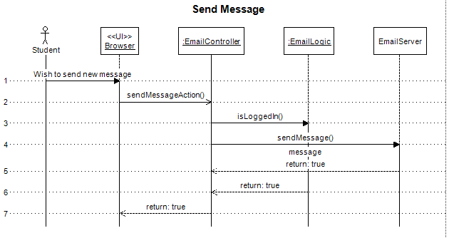
3.7.7 Receive Emails:
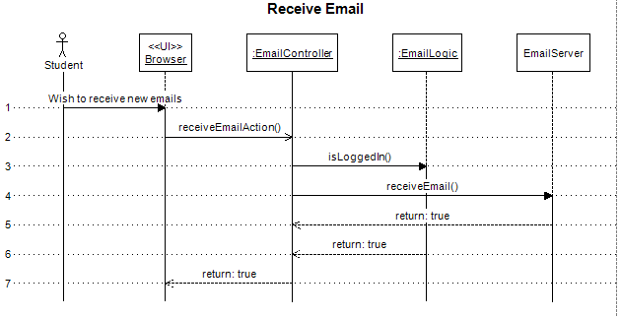
3.7.8 Set Flag:
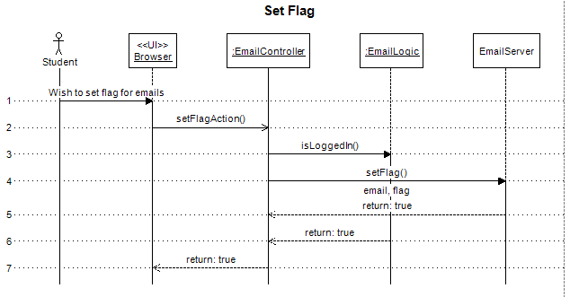
3.7.9 Set Reminder:
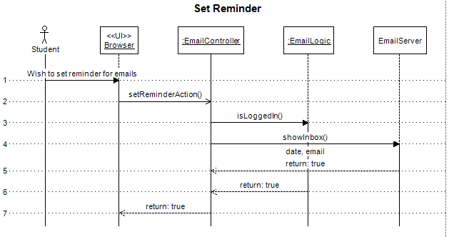

3.8 OBJECT MODEL/LOGICAL MODEL: CLASS DIAGRAM
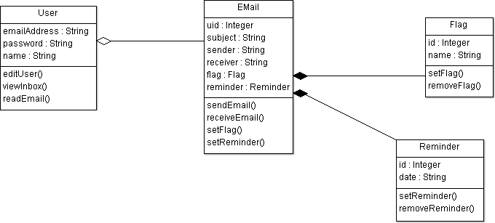

3.9 IMPLEMENTATION VIEW
3.9.1 Overview

3.10 DEPLOYMENT MODEL

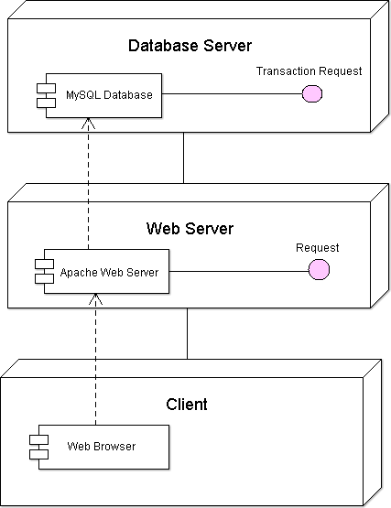

3.11 DATABASE MODEL

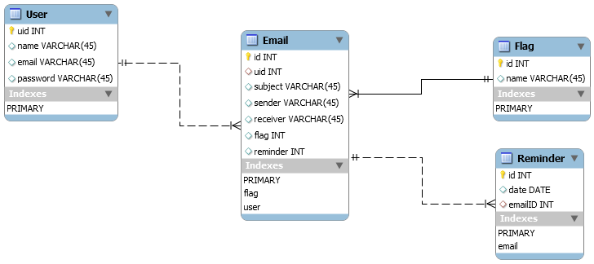

3.12 GRAPHICAL USER INTERFACES

3.12.1 Login:
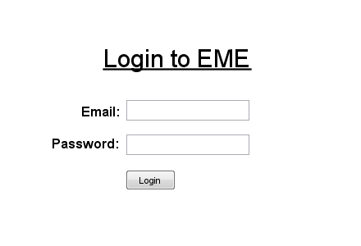

3.12.2 Inbox:

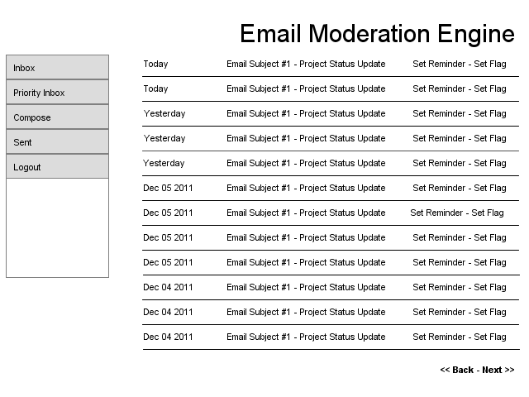

3.12.3 Set Priority:

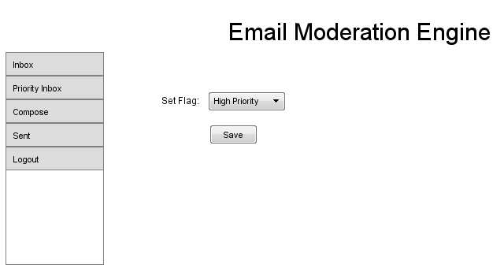

3.12.4 Set Reminder:

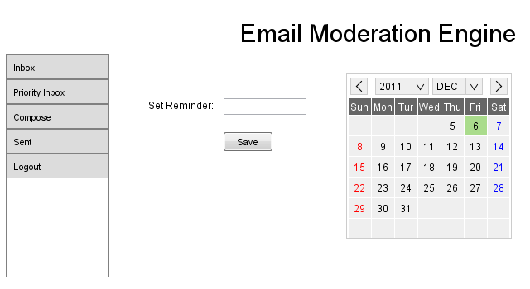

CHAPTER 4
Development

4.1 DEVELOPMENT PLAN
4.1.1 Evaluation

After going through the analysis and design phase, I started evaluating different platform and technologies which I was thinking would be helpful in development.

As I was planning to do the development on my local desktop PC with a moderate hardware, I wanted an environment which offers good performance and speed. Also, I wanted the learning curve to be less.

I selected AMP (Apache, MySQL and PHP) as my development environment and it was very easy to setup this on my PC in almost no time.

For email server, instead of going with an online server, I opted for hMail which offered same email facilities with much faster pace. I was able to do my development and testing without even connecting to internet when everything was setup.

4.1.2 Framework

When I chose to work with PHP as my coding language, I also explored some frameworks such as Zend, Symfony and Yii.

When evaluating these frameworks, I realized the amount of setup and learning time they would require is more than what our project would actually require. So I didn’t chose any of them.

4.1.3 Custom MVC

After evaluating these frameworks, I realized the best way for this project would be to go with MVC (Model View Controller) pattern. I opted for a custom MVC which I built myself with some very basic features.

I have now developed the whole application using this custom framework.

4.2 SOURCE CODE
Source code is attached.

CHAPTER 5
Deployment

5.1 DEPLOYMENT PLAN
5.1.1 Setup Requirement

This application will require the following before attempting to deploy on a server:

1. Windows or any *unix server
2. Apache
3. PHP 5.3.x
4. PHP Pear Net and Mail libraries
5. MySQL
6. Access to POP server with valid email address.
7. Access to SMTP server with valid email address and sending permission.

5.1.2 Deployment
To deploy this application user need to follow the following:

- Copy the code files (attached with this document) to the DocumentRoot folder of Apache.
- Setup the required variables in main configuration file named conf.php
- Create a database named vu_eme in MySQL.
- Import the sql from attached source into this database.
- In database table vu_eme.user, update the user entry for email address and password you would like for which to use this application.
- Now access this application from browser as http://localhost/eme/index.php
- For further installation help, please consult to the INSTALL.txt file in source code directory.

REFERENCES

APPENDIX

